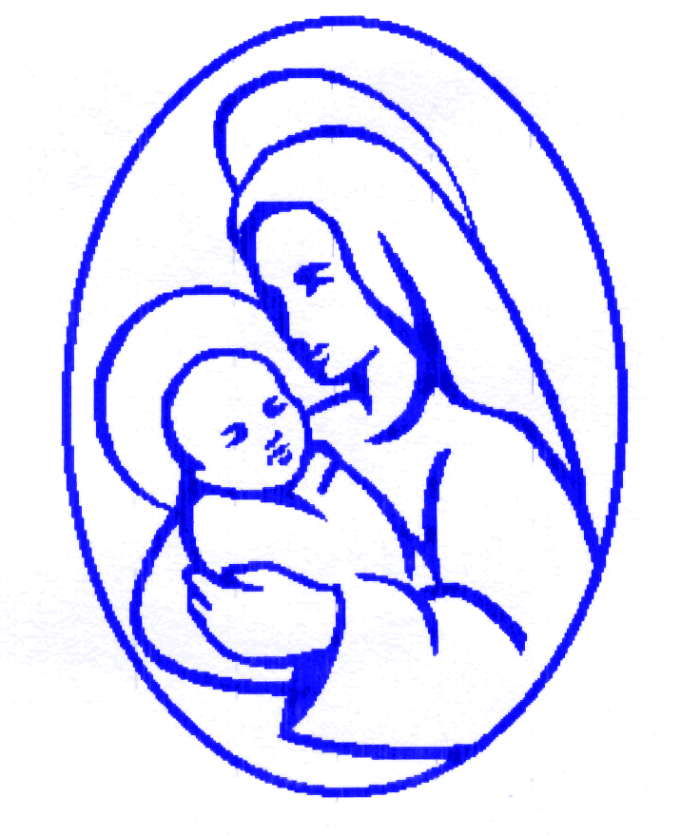

ST MARY’S PRIMARY SCHOOL HOLIDAY PATTERN

2024/2025

Family Holidays: Children benefit from attending school as often as possible. Term time holidays will not be authorised by schools and their Governing Bodies unless they meet the Governments specific criteria issued to schools. Any holidays taken during term time will be unauthorised and parents may be subject to a fixed penalty fine.

SCHOOL OPENS TUESDAY 3 SEPTEMBER 2024

AUTUMN HALF TERM Monday 28 Oct – Friday 1 Nov 2024

CHRISTMAS Monday 23 Dec – Monday 6 Jan 2025

SPRING HALF TERM Monday 17 Feb - Friday 21 Feb 2025

EASTER Monday 7 April – Monday 21 April 2025

MAY DAY Monday 5 May 2025

SUMMER HALF TERM Monday 26 May – Friday 30 May 2025

INSET DAY Monday 9 June 2025

SUMMER HOLIDAY Monday 21 July – Tuesday 2 Sept 2025

