Subject | Term 1  (Sept-Oct) | Term 2  (Nov/Dec) | Term 3  (Jan/Feb) | Term 4  (Mar/April) | Term 5  (May/June( | Term 6  (July/Aug)
 | Genre:  Fables  Narratives  Dialogue and Plays  Key Texts:  The Hare and  The Tortoise  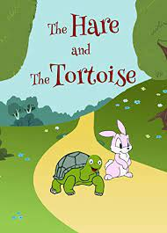  Narrative  Stone Age Boy  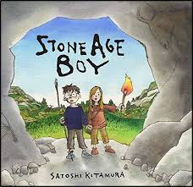  Jack and Jill  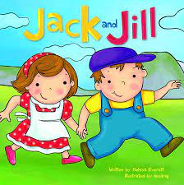 | Genre:  Myths  Non Chronological Reports  Character Development  Key Texts:  Theseus and the Minotaur  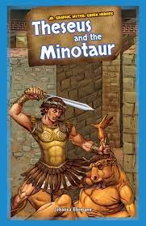  Medusa  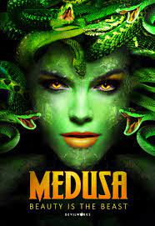  Stone Age Report  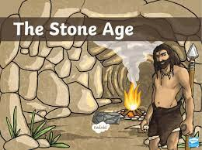  Character Development:  The Christmas Miracle of Jonathan Toomey  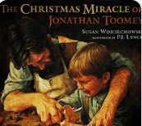 | Genre:  Mystery stories  Language play poems  Key Texts:  The 25th December  Incident  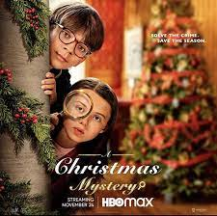  The Mystery of the Bookcase  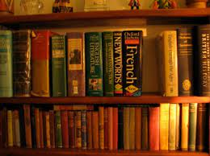  Shape Poems  Calligrams  Pyramid poems  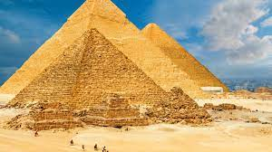  Shape Poems  Calligrams  Shape poems - raindrops and love hearts  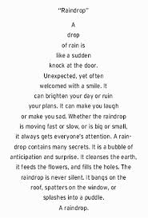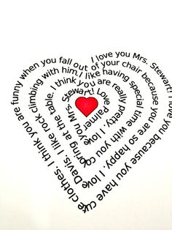 | Genre:  Instructions, Procedural eg rules of a game  diary entry  Performance poems  Key Texts:  George’s Marvellous Medicine  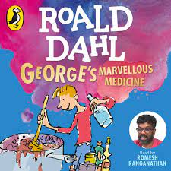  Procedural  Beware of Boys  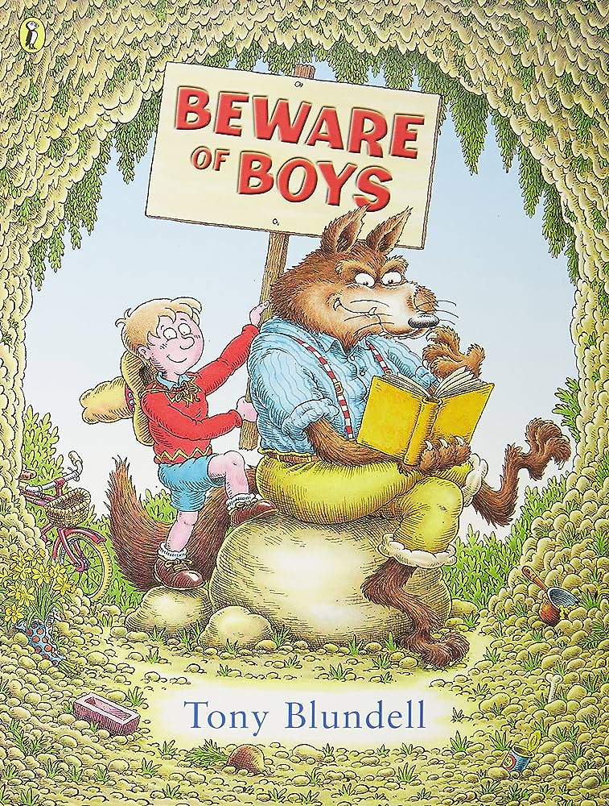  Tadeo Jones - Ancient Egypt Tomb Raider  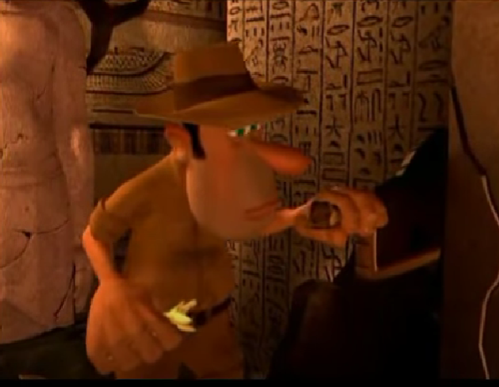 | Genre:  Information text  Character description  Persuasive text  Key Texts  Mythical Monsters - information text  (Pie Corbett)  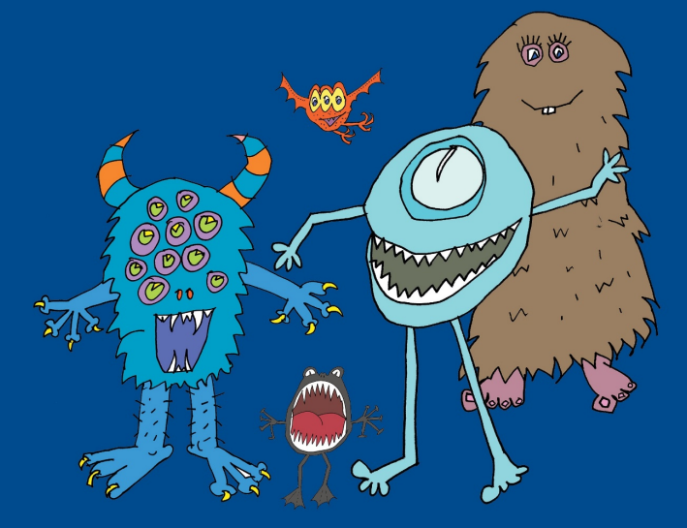  Poetry  Language Poem  In the Land of the Bumbley Boo  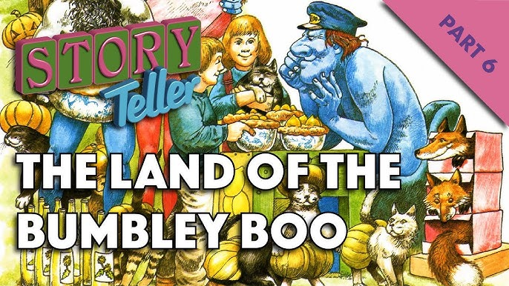  Persuasive Text  Write a Holiday Advert - Fictional Seaside town  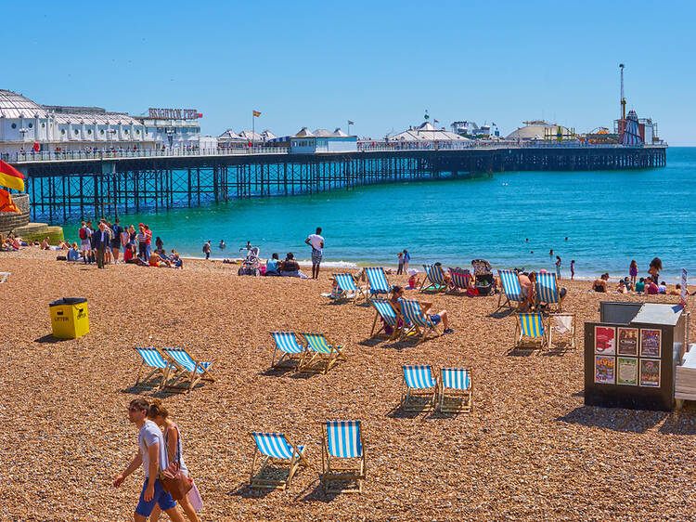  The Twits  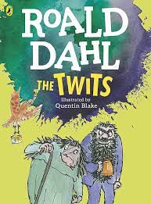 | Genre:  Letters  Performance poem  Shape poems/calligrams  Key Texts  Letter to an inspirational person    Performance Poem  Please Mrs. Butler  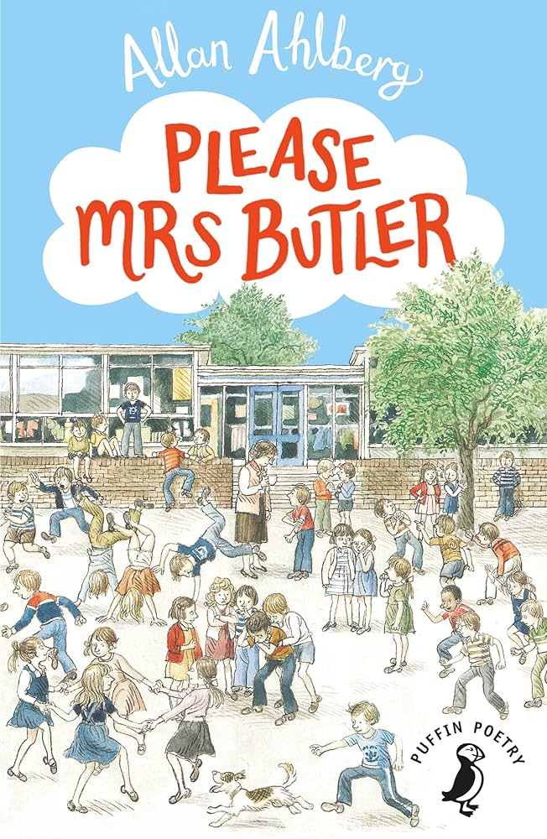  Information Text on Rivers  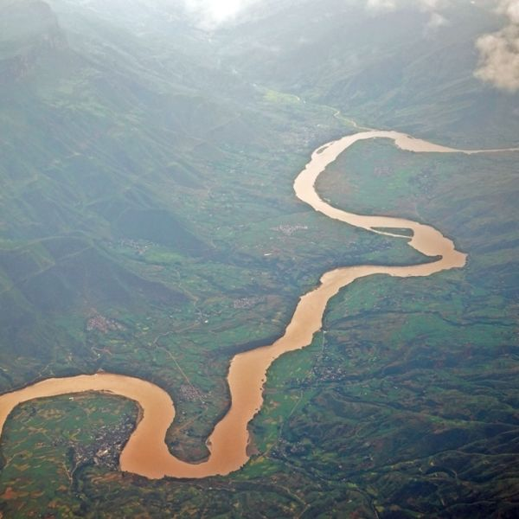  Letter to Year 2 pupils: how to survive Year 3  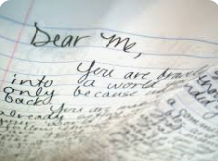
English | Grammar  Conjunctions to express time, place and cause.g. when,before,after,while,so,  because  (complex sentences)  Adverbs  Forms ‘a’ or ‘an’ according to whether word begins with a vowel or consonant.  Using and punctuating direct speech  Use and understand grammatical terminology | Grammar  Conjunctions, adverbs,  Prepositions to express time, place and cause e.g before, after, during, in, because of  (complex sentences)  Paragraphs to organise ideas  Headings/ sub headings.  Using and punctuating direct speech  Use and understand grammatical  terminology | Grammar  Conjunctions, adverbs, prepositions  Clauses  Sub ordinate Clauses  (complex sentences)  Introduce fronted adverbials  Using and punctuating direct speech  Use and understand grammatical terminology | Grammar  Conjunctions, adverbs, prepositions  Clauses  Sub ordinate Clauses  (complex sentences)  Fronted adverbials  Using and punctuating direct speech  Use and understand grammatical terminology | Grammar  Recognize some different forms of poetry  identifying main ideas drawn from more than one paragraph and summarising  these  retrieve and record information from non-fiction | Grammar  Paragraphs.  Conjunctions  Adverbs  Prepositions  Present perfect form of verbs  First and third person  Use and understand grammatical terminology
 | Punctuation  Revise capital letters, full stops, exclamation marks and question marks (Y2 revision)  Introduce inverted commas to punctuate speech. | Punctuation  Conjunctions, adverbs,  Prepositions to express time, place and cause e.g before, after, during, in, because of  (complex sentences)  Paragraphs to organise ideas  Headings/ sub headings.  Using and punctuating direct speech | Punctuation  Revise capital letters, full stops, exclamation marks and question marks (Y2 revision)  Using a comma after a fronted adverbial  Question marks (Y2) | Punctuation  Inverted commas to punctuate speech.  Commas in list (Y2 revision)  Colon for instructions | Punctuation  Possessive apostrophe with plural nouns  Paragraphs.  Headings/ Sub Headings  Choosing nouns or pronouns appropriately for clarity and cohesion and to avoid repetition | Punctuation  Revise capital letters, full stops, exclamation marks and question marks (Y2 revision)  Inverted commas to punctuate speech.
Spellings | Words with the long /ai/ sound spelt with ei  Words with the long /ai/ sound spelt with ey  Words with long /ai/ sound spelt with ai  Words with the /ur/ sound spelt with ear  Homophones and near homophones | Creating adverbs using the -’ly’ (no change to root word)  Creating adverbs using the suffix -ly (root word ends in ‘y’ with more than one syllable)  Creating adverbs using the suffix -ly (root word ends in ‘le’)  Creating adverbs using the suffix -ly (root word ends in ‘ic’ or ‘al’)  Creating adverbs using the suffix -ly (exceptions to the rules)  Statutory Spelling Challenge Words | Words with short /i/ sound spelt with ‘y’  Adding suffixes with a vowel (er, ed, ing) to words with more than one syllable - DO NOT double the consonant  Adding suffixes with a vowel (er, ed, ing) to words with more than one syllable - add the double the consonant  Creating negative meanings using the prefix /mis/  Creating negative meanings using prefix /dis/  Words with a /k/ sound spelt with ‘ch’ | Homophones and near homophones  Adding the prefix /bi/ (meaning two or twice) and adding the prefix /re/ (meaning again or back)  Words ending in the /g/ sound spelt ‘gue’ and the /k/ sound spelt /que/  Words with a /sh/ sound spelt with ‘ch’  Statutory Challenge words | Words ending in -ary  Words with short /u/ sound spelt with ‘o’  Words with a short /u/ sound spelt with ‘ou’  Word families based on common words | Words ending in the suffix ‘al’  Words ending with a /zhuh/ sound spelt ‘sure’  Words ending with a /chuch/ sound spelt ‘ture’  Silent letters
Maths | Number -Place Value  Identify, represent and estimate numbers using different representations.  Find 10 or 100 more or less than a given number.  Place value of each digit in a 3-digit number.  Compare/order numbers up to 1000.  Read/write numbers up to 1000 in numerals and words.  Solve number problems and practical problems involving these ideas.  Count from 0 in multiples of 4, 8, 50 and 100  Addition and Subtraction  Add/subtract mentally – 3- digit numbers +/- ones, tens, hundreds.  Add and subtract numbers with up to three digits, using formal written methods of columnar addition and subtraction.  Estimate the answer to a calculation and use inverse operations to check answers.  Solve problems, including missing number problems, using number facts, place value, and more complex addition and subtraction.  Multiplication and Division  Count from 0 in multiples of 4, 8, 50 and 100. Recall and use multiplication and division facts for the 3, 4 and 8 multiplication tables.  Write and calculate mathematical statements for multiplication and division using the multiplication tables they know, including for two-digit numbers times one-digit numbers, using mental and progressing to formal written methods.  Solve problems, including missing number problems, involving multiplication and division, including positive integer scaling problems and correspondence problems in which n objects are connected to m objectives. |  | Number – multiplication and division  Write and calculate mathematical statements for multiplication and division using the multiplication tables they know, including for two-digit numbers times one-digit numbers, using mental and progressing to formal written methods.  Solve problems, including missing number problems, involving multiplication and division, including positive integer scaling problems and correspondence problems in which n objects are connected to m objectives.  Measurement -money  Add and subtract amounts of money to give change, using both £ and p in practical contexts.  Statistics  Interpret and present data using bar charts, pictograms and tables.  Solve one-step and two-step questions [for example, ‘How many more?’ and ‘How many fewer?’] using information presented in scaled bar charts and pictograms and tables.  Measurement – length and perimeter Measure, compare, add and subtract: lengths (m/cm/mm); mass (kg/g); volume/capacity (l/ml).  Measure the perimeter of simple 2-D shapes.  Fractions  Recognise and use fractions as numbers: unit fractions and non-unit fractions with small denominators. |  | Number- Fractions  Recognise and use fractions as numbers: unit fractions and non-unit fractions with small denominators.  Count up and down in tenths; recognise that tenths arise from dividing an object into 10 equal parts and in dividing one-digit numbers or quantities by 10.  Recognise, find and write fractions of a discrete set of objects: unit fractions and non-unit fractions with small denominators.  Equivalent fractions.  Add/subtract fractions with the same denominator. Compare/order fractions with the same denominator.  Solve problems that involve all of the above.  Measurement -Time  Tell and write the time – 12 and 24 hour clocks. Estimate and read time with increasing accuracy to the nearest minute;record and compare time in terms of seconds minutes and hours; use vocabulary such as o’clock, a.m ./p.m., morning, afternoon, noon and midnight.  Know the number of seconds in a minute and number of days in each month, year and leap year.  Compare duration of events.  Geometry - Properties of shape  Draw 2d shape.  Make 3d shapes.  Recognise 3d shapes in different orientations and describe them.  Recognise angles as a property of shape or description of a turn.  Identify right angles, recognise that two right angles make a half turn, three make three quarters of a turn and four a complete turn; identify whether angles are greater than or less than a right angle.  Identify horizontal and vertical lines and pairs of perpendicular and parallel lines.  Measurement - Mass and Capacity  Measure, compare, add and subtract, mass, volume/capacity
Science | Rocks -  Strand Chemistry  What’s hidden below the surfaces? … let’s take a peek!  compare and group together different kinds of rocks on the basis of their appearance and simple physical properties  describe in simple terms how fossils are formed when things that have lived are trapped within rock  recognise that soils are made from rocks and organic matter  Linked with work in geography pupils should explore different types of rocks and soils identifying the similarities and differences between them and investigate what happens when rocks are rubbed together and what changes can occur when they are in water.  observing rocks, including those used in buildings and gravestones, and exploring how and why they might have changed over time;  classify rocks according to whether they have grains or crystals, and whether they have fossils in them. | Forces and Magnets - Strand Physics  Can the force be with you ?  compare how things move on different surfaces  notice that some forces need contact between 2 objects, but magnetic forces can act at a distance  observe how magnets attract or repel each other and attract some materials and not others  compare and group together a variety of everyday materials on the basis of whether they are attracted to a magnet, and identify some magnetic materials  describe magnets as having 2 poles  predict whether 2 magnets will attract or repel each other, depending on which poles are facing  observe that magnetic forces can act without direct contact.  explore the behaviour and everyday uses of different magnets  work scientifically by: comparing how different things move and grouping them; raising questions and carrying out tests to find out how far things move on different surfaces and gathering and recording data to find answers their questions;  explore the strengths of different magnets and find a fair way to compare them;  sort materials into those that are magnetic and those that are not; looking for patterns in the way that magnets behave in relation to each other.  identify how these properties make magnets useful in everyday items and suggesting creative uses for different magnets. | Animals Including Humans- Strand: Biology  Teeth, skeleton, muscles, medicines, nutrition  If you didn’t have a skeleton, what would it stop you doing?  identify that animals, including humans, need the right types and amount of nutrition, and that they cannot make their own food; they get nutrition from what they eat  identify that humans and some other animals have skeletons and muscles for support, protection and movement  Identify the different types of teeth in humans and their simple functions.  Learn about the importance of nutrition and should be introduced to the main body parts associated with the skeleton and muscles, finding out how different parts of the body have special functions.  Identify and group animals with and without skeletons and observing and comparing their movement; exploring ideas about what would happen if humans did not have skeletons. They might compare and contrast the diets of different animals (including their pets) and decide ways of grouping them according to what they eat.  Research different food groups and how they keep us healthy and design meals based on what they find out. | Light Strand: Physics  Can I leave my shadow behind?  recognise that they need light in order to see things and that dark is the absence of light  notice that light is reflected from surfaces  recognise that light from the sun can be dangerous and that there are ways to protect their eyes  recognise that shadows are formed when the light from a light source is blocked by an opaque object  find patterns in the way that the size of shadows change  explore what happens when light reflects off a mirror or other reflective surfaces  Learn why it is important to protect their eyes from bright lights  Look for, and measure, shadows, and find out how they are formed and what might cause the shadows to change.  Know that it is not safe to look directly at the Sun, even when wearing dark glasses.  Look for patterns in what happens to shadows when the light source moves or the distance between the light source and the object changes. | Plants -  Strand: Biology  How well does your garden grow?  identify and describe the functions of different parts of flowering plants: roots, stem/trunk, leaves and flowers explore the requirements of plants for life and growth (air, light, water, nutrients from soil, and room to grow) and how they vary from plant to plant  investigate the way in which water is transported within plants  explore the part that flowers play in the life cycle of flowering plants, including pollination, seed formation and seed dispersal.  Understand the role of the roots and stem in nutrition and support, leaves for nutrition and flowers for reproduction  be introduced to the idea that plants can make their own food  compare the effect of different factors on plant growth, for example, the amount of light, the amount of fertiliser; discovering how seeds are formed by observing the different stages of plant life cycles over a period of time; looking for patterns in the structure of fruits that relate to how the seeds are dispersed.  observe how water is transported in plants, for example, by putting cut, white carnations into coloured water and observing how water travels up the stem to the flowers
 | Working Scientifically: Recording data; Identifying scientific evidence; Planning enquiries (including recognising / controlling variables); Using test results to make predictions and set up further tests; Report and present findings; Take measurements using a range of scientific equipment.
Religious Education | What do Christians learn from the creation story? (Creation) | How do festivals and family life show what matters to Jews? (God/Torah/the People) | What is it like for someone to follow God? (People of God) | How do festivals and worship show what matters to a Muslim? (Ibadah) | What is the ‘Trinity’ and why is it important for Christians? (God/Incarnation) | How and why do people try to make the world a better place?
Computing | E Safety to include emails  Think before you share and Respect  Understand once an online message has been sent it can’t be taken back  You tube – I don’t want everybody to see my bum  You tube – She sent me a poo  Digiduck  How to respond if being asked for personal information  Think You Know –lesson 3  Azoome – Search it up ‘I’ve Won’  Use email address book  Open and send an attachment  Purple mash – Unit 3.5 Emails  Can I create strong passwords and understand privacy settings?  Twinkl – E-safety – Year 3 – Lesson 3 – Keep it to yourself | Data retrieving and organising  Create a graph from a database  Purple mash - 2 investigate  Create simple branching database, identify objects, question to classify data  Purple Mash Unit 3.6 Branching | Algorithms and Programs  Plan complex series of instructions for screen and floor turtles and test and amend instructions for purpose  Purple Mash 2 logo | Algorithms and Programs  Create basic applications, investigating how different variables can be changed  Purple Mash –Unit 3.1 Coding  Explore simulations and discuss benefits  Use simulations to make and test predictions.  Lego WeDo- Roaring lion and hungry alligator | Communicating and Presentation  Create a publishing tool to create a poster or a leaflet  Desktop publishing  Create presentation using powerpoint  Changes layout of slides and adding images and sounds  Powerpoint | Communicating and Presentation  Sequence short pieces of music using pre-recorded sounds  Purple Mash 2 Sequence
 | E Safety will be revisited at the start of each half term
Geography |  |  |  |  | Human and Physical Geography  Are all rivers raging ?  Rivers/Mountains/UK  Describe and understand key aspects of:  - physical geography, including: rivers, mountains and the water cycle.  Name and locate within the United Kingdom key topographical features :  - hills, mountains, coasts and rivers  Use maps, atlases, globes and digital/computer mapping to locate countries and describe features studied.  Use symbols and key (including the use of Ordnance Survey maps) to build their knowledge of the United Kingdom  Use fieldwork to observe, measure, record and present the human and physical features in the local area using a range of methods, including sketch maps, plans and graphs, and digital technologies. (Covered in Y3 and Year 5)
 | Ongoing development of geographical skills and fieldwork
History | Who First Lived in Britain?  Changes in Britain from Stone Age to Iron Age  Late Neolithic hunter- gatherers and early farmers  Bronze age to Iron Age  Changes in Britain from Stone Age to Iron Age  Late Neolithic hunter-gatherers and early farmers - Skara Brae.  The Bronze Age religion, technology and travel - Stonehenge.  Iron Age hill forts: tribal kingdoms, farming, art and culture.  Daily life, homes, hunting, farming, inventions and culture. |  | Could you be a tomb raider?  The achievements of the earliest civilizations - an overview of where and when the first civilizations appeared: Ancient Sumer; The Indus Valley; Ancient Egypt; The Shang Dynasty of Ancient China.  In depth study of Ancient Egypt and its achievements.
 | Ongoing development of chronological understanding and historical enquiry skills
Art | Drawing  Experiment with the potential of various pencils (at least 3 different grades) show different tones; show tone & texture?  Incorporate charcoal and pastels, close observation.  Draw images of stone, bronze and iron age homes/weapons/cooking utensils/artefacts  Group cave art (pastels) |  | Modroc/Clay  Shape and form.  Show sufficient control to join and manipulate materials for the purpose intended?  Add onto your work to create texture and shape?  Create Egyptian Mummy using modroc and decorate by painting. |  | Painting  Colour mixing.  Introduce different types of brushes.  Techniques- apply colour using dotting, scratching, splashing.  Mix colours of paint to recreate ‘The River’ by Cezanne’s Bridge of Maincy  Use different brushes to recreate Cezanne’s ‘Bridge of Maincy’  George Seurat – River Seine - Pointillism | Collage  Select colours and materials to create effect, giving reasons for their choices.  Refine work as they go along to ensure precision  Learn and practise a variety of techniques eg overlapping, tessellation, mosaic and montage
 |  |  |  |  | Artist to be studied: George Seurat
Design Technology | Mechanisms  Levers and Linkages  Christmas Card |  | Food  Healthy Eating and Food Origins  Healthy Sandwiches |  | Structures  Joining, stiffening, strengthening  Pyramids
Key Individual to study:
Gaudi - Sagrada Familia – Link with MFL
Physical education  (PE) | Invasion Games  Game Sense: zoning, spatial awareness  (Football)  Swimming | Dance  Witches and Wizards  Swimming | Gymnastics  Symmetry and Asymmetry  Swimming | Gymnastics  Canon and Unison  Swimming | Games  Net and Wall  Tennis  Swimming | Athletics  Running and sprinting Swimming
Languages  (Spanish)  2024-2025 | Yo  (All About Me) |  | Canciones y juegos  (Games and Songs) |  | Vamos a celebrarlo!  (Celebrations)
2025 onwards | I am learning Spanish |  | Animals & Instruments |  | I am able to..  I know how to…  Ice creams or fruits or vegetables
RSHE  (inc British Values and RSE) | Family and people who care for us  (R1.3)  Being Safe  (R5.4) | Caring friendships  (R2.3)  Respectful relationships  (R3.3, R3.4) | Online Relationships  (R4.1)  Internet Safety and harms  (H7.3, H7.4) | Mental wellbeing  (H6.5, H6.6)  Basic first aid  (H12.2) | Health and prevention  (H11.1, H11.5) | Physical health and fitness  (H8.2)  Healthy eating  (H9.1)
British Values | Rule of Law: How/why rules and laws are made and enforced, including school rules  Democracy: Election of School Council  Individual Liberty: Making the correct, healthy choices  Tolerance of Different Faiths and beliefs: Jewish Faith - Sukkhot |  | Tolerance of Different Faiths and beliefs: Jewish Faith - Passover |  | Mutual Respect: Recognise peoples’ feelings and realising that most friendships have ups and downs R2.4  Show, respect, constructively challenge different points of view R3.5  Personal boundaries R5.3  Tolerance of Different Faiths and beliefs: Jewish Faith – sacred books, sacred places, visit to Jewish Synagogue
Economic Awareness |  |  | Money Matters:  Where does money come from?  Lending and Borrowing  Budgeting.
Music | Pitch  Performing  Composing and Improvising  Listening and Appraising  Vocal Skills  Music Express : China  Autumn 1 | Pitch  Notation  Performing  Composing and Improvising  Listening and Appraising  Vocal Skills  Music Express :  in The Past | Beat  Performing  Composing and Improvising  Listening and Appraising  Vocal Skills  Music Express : Building | Structure  Performing  Composing and Improvising  Listening and Appraising  Vocal Skills  Music Express : Human Body | Performance  Performing  Composing and Improvising  Listening and Appraising  Vocal Skills  Music Express : Food And Drink | Composition  Performing  Composing and Improvising  Listening and Appraising  Vocal Skills  Music Express :  Environment

